1.(1) 12 (2) 6 (3) 8
2.
#pragma warning(disable:4996)
#include <stdio.h>
#include <string.h>
int main() {
char ss[2][50] = { '\0' };
scanf("%s%s", ss[0], ss[1]);
if (strcmp(ss[0], ss[1]) > 0)
printf("%s\n%s\n", ss[1], ss[0]);
else
printf("%s\n%s\n", ss[0], ss[1]);
return 0;
}
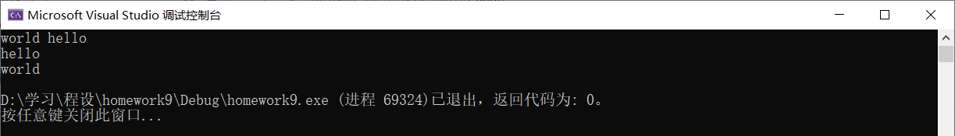
3.
#pragma warning(disable:4996)
#include <stdio.h>
int main() {
char* p[5] = { "File" , "Edit" , "Write" , "Read" , "Exit" };
for (int i = 0; i < 5; ++i) {
printf("%s\n", p[i]);
}
return 0;
}
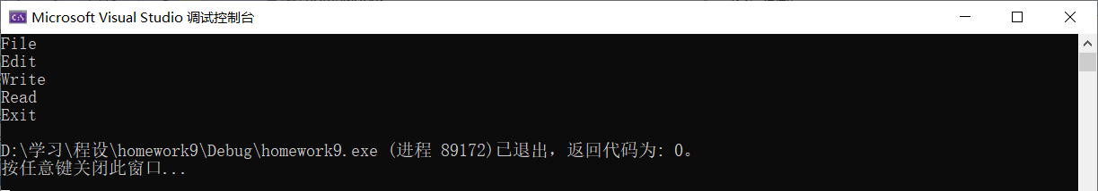
4.
#pragma warning(disable: 4996)
#include <stdio.h>

void disp(char *s, int n)
{
for (int i = 0; i < n; ++i)
if (s[i]) putchar(s[i]);
else break;
}

int main()
{
char s[50];
scanf("%s", s);
//Strings in C language begin at Position 0, so the 4th character should be s[3]
disp(s + 3, 7);
return 0;
}

11.
#pragma warning(disable:4996)
#include <stdio.h>
#include <stdlib.h>
int main(int argc, char* argv[]) {
for (int i = 0; i < argc; ++i) {
printf("%s\n", argv[i]);
}
system("pause");
return 0;
}
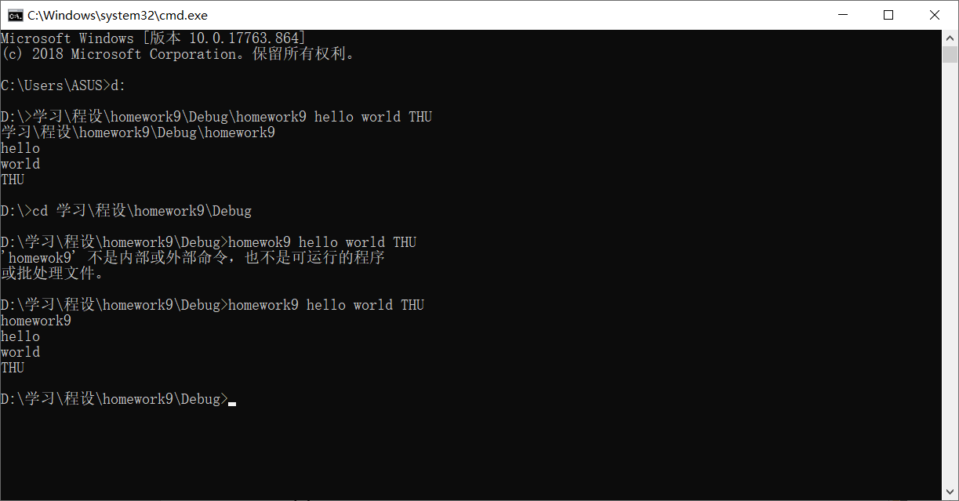
12.
#include <stdio.h>
#include <math.h>
#pragma warning(disable:4996)
void Exp(double* x, double* y, double* u, double* v) {
double u0 = exp(*x) * cos(*y), v0 = exp(*x) * sin(*y);
*u = u0;
*v = v0;
}
void Ln(double* x, double* y, double* u, double* v) {
double u0, v0;
u0 = log(sqrt((*x) * (*x) + (*y) * (*y)));
v0 = atan(*y / *x);
*u = u0;
*v = v0;
}
void Sin(double* x, double* y, double* u, double* v) {
double u0, v0, ey;
ey = exp(*y);
u0 = sin(*x) * (ey + 1 / ey) / 2;
v0 = cos(*x) * (ey - 1 / ey) / 2;
*u = u0;
*v = v0;
}
void Cos(double* x, double* y, double* u, double* v) {
double u0, v0, ey;
ey = exp(*y);
u0 = cos(*x) * (ey + 1 / ey) / 2;
v0 = -sin(*x) * (ey - 1 / ey) / 2;
*u = u0;
*v = v0;
}
int main() {
double x = 2.0, y = 3.0;
printf("exp(%lf+j%lf)=", x, y);
Exp(&x, &y, &x, &y);
printf("%lf+j%lf\nln(%lf+j%lf)=", x, y, x, y);
Ln(&x, &y, &x, &y);
printf("%lf+j%lf\nsin(%lf+j%lf)=", x, y, x, y);
Sin(&x, &y, &x, &y);
printf("%lf+j%lf\ncos(%lf+j%lf)=", x, y, x, y);
Cos(&x, &y, &x, &y);
printf("%lf+j%lf\n", x, y);
return 0;
}
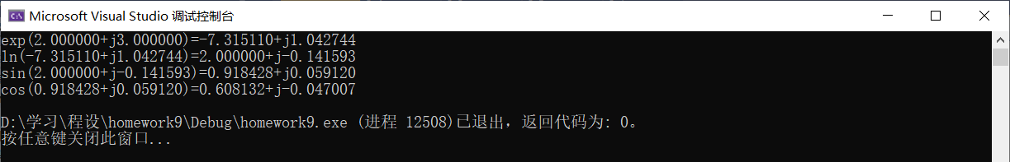
13.
#include <stdio.h>
#include <string.h>
void Sort(char* p[], int n) {
int k = 0, m = n - 1, m0, k0;
while (k < m) {
m0 = m;
m = k;
for (int i = k ; i < m0 ; ++i)
if (strcmp(p[i], p[i + 1]) > 0) {
char* tmp = p[i];
p[i] = p[i + 1];
p[i + 1] = tmp;
m = i;
}
k0 = k;
k = m;
for (int j = m; j > k0; --j) {
if (strcmp(p[j], p[j - 1]) < 0) {
char* tmp = p[j];
p[j] = p[j - 1];
p[j - 1] = tmp;
k = j;
}
}
}
}
int main() {
char* p[] = { "zhang" , "gou", "xu" , "zheng" , "mao" , "zhao" , "li" , "bai" , "qing" };
for (int i = 0; i < 9; ++i)
printf("%s ", p[i]);
Sort(p, 9);
printf("\n");
for (int i = 0; i < 9; ++i)
printf("%s ", p[i]);
return 0;
}

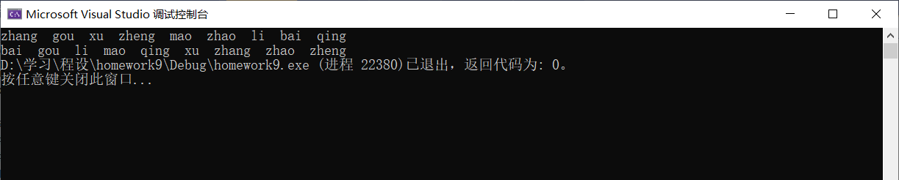

探究题：
#pragma warning (disable:4996)
#include <stdio.h>
#include <string.h>
#include <malloc.h>
char* my_replace(char* s1, char* s2, char* s3) {
char *s4 = (char*)malloc(sizeof(char) * 1000);
char* p , *p1 = s4 , *p2 = s1;
int len2 = strlen(s2), len3 = strlen(s3), dt;
p = strstr(s1, s2);
while (p) {
dt = p - p2;
strncpy(p1, p2, dt);
p1 += dt;
strncpy(p1, s3, len3);
p1 += len3;
p2 += dt + len2;
p = strstr(p2, s2);
}
strcpy(p1, p2);
return s4;
}
int main() {
char* s;
char s1[100], s2[20], s3[20];
scanf("%s%s%s", s1, s2, s3);
s = my_replace(s1, s2, s3);
printf("%s", s);
free(s); //释放函数my_replace中的malloc！！！
return 0;
}
